**1.) Modifications to Week 1 Deliverable**

* Charge customers for temperature and rinse change in custom cycles.
* Washing machine will send an e-receipt to email or phone number (out of scope).
* Have an emergency abort option to abort wash cycle.

**2.) Note: Priority weight scale is 1 – 5 (1 is highest; 5 is lowest)**

UC1 (2) Card Payments

UC2 (1) Coin Payments

UC3 (1) Preprogrammed Cycle

UC4 (2) Custom Cycle

UC5 (3) Sanitary Rinse

UC6 (4) Display Machine data

UC7 (1) Abort Cycle

**3.) Requirements – Use Case Traceability Matrix**

| **Requirement** | **Priority** | **UC1** | **UC2** | **UC3** | **UC4** | **UC5** | **UC6** | **UC7** |
| --- | --- | --- | --- | --- | --- | --- | --- | --- |
| **R1** | **1** |  |  | x |  |  |  |  |
| **R2** | **1** | x | x |  |  |  |  |  |
| **R3** | **2** |  |  | x | x | x |  | x |
| **R4** | **2** |  |  | x |  |  |  |  |
| **R5** | **3** |  |  |  | x |  |  |  |
| **R6** | **4** |  |  | x |  | x |  |  |
| **R7** | **6** |  |  |  |  |  | x |  |
| **R8** | **8** |  |  |  |  |  | x |  |
| **R9** | **8** |  |  |  |  |  | x |  |
| **UC Priority** | | **2** | **1** | **1** | **2** | **3** | **4** | **1** |

**4.) Use Case Diagram**

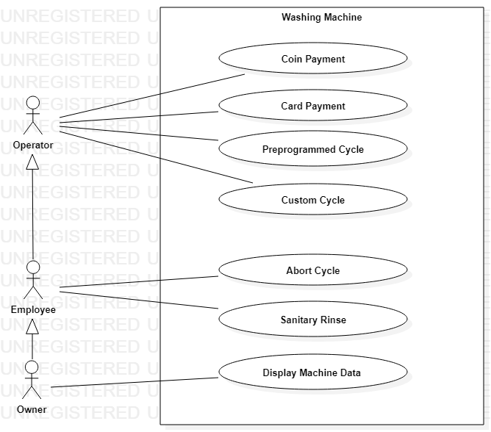

**5.) Use Case Narratives**

**UC3 Preprogrammed Cycles**

1. The machine displays the message, “To begin washing clothes, please select a cycle”.
2. The customer selects their preprogrammed cycle option.
3. The machine displays the message, “Please confirm cycle”.
4. If the customer selects “Yes”, the machine will load the settings for the selected cycle.
5. If the customer selects “No”, the machine returns to step 1.
6. The machine displays the message, “Insert clothes and pour detergent”.
7. If the customer does not open the door within 5 minutes, the machine returns to step 1.
8. The customer opens the door and places laundry and detergent in the machine.
9. The machine displays the message, “Please close door”.
10. If the customer does not close the door, the machine warns the customer.

i. After 5 minutes the machine beeps once.

ii. After 10 minutes the machine returns to step 1 and beeps continuously.

1. If the customer attempts to pay before the door is closed, the machine displays the message, “Close door before payment”.
2. The customer closes the door.
3. The machine sees that the door is closed and proceeds to payment use cases.

**UC2 Coin Payments**

1. The machine displays the price of the selected cycle.
2. The machine displays the message, “Please insert payment”.
3. The customer inserts coins into the machine.
4. The machine deducts the inserted coin amount from the cycle price.
5. If the coin release is pressed, the coins are returned to the customer and the cycle is aborted.
6. When the inserted coin amount is equal to the cycle price, the machine displays the message, “Press start”.
7. If the customer doesn’t press the start button within 5 minutes, the machine will beep continuously.
8. The customer presses the start button.
9. The machine confirms that the door is closed.
10. If the door is not closed, the machine displays the message, “Please close door”.
11. If the customer does not close the door, the machine warns the customer.

i. After 5 minutes the machine beeps once.

ii. After 10 minutes the machine beeps continuously.

1. If the door is closed, the machine locks the door.
2. The machine begins the wash cycle.
3. When the wash cycle ends, the machine displays the following message, “Cycle finished, please remove clothes”.
4. The machine unlocks the door.
5. The Customer opens the door.
6. The machine returns to the main menu.

**UC7 Abort Wash Cycle**

1. The employee presses the abort button during the wash cycle.
2. The machine displays the message, “Please enter the pin”.
3. The employee enters their pin number.
4. The machine verifies the employee’s pin number.
   1. If the pin is incorrect, the machine displays the message, “Incorrect, please try again”.

i. If the pin is incorrectly entered an additional time, Machine exits ‘Abort Wash Cycle’.

ii. The machine beeps continuously.

* 1. If the pin is correct, continue.

1. The machine displays the message, “Abort cycle?”.
2. If the employee selects “No”, the machine returns to the current cycle.
3. If the employee selects “Yes”, the machine stops all processes.
4. The machine opens the drain.
5. The machine unlocks the door.
6. The machine returns to the main menu.